Database Platform Migration

🌟 Definition
# Source: AI Source: Provided by: [Data Path: Persons Table -> ID Column: 1, Name_En Column: Motasem Essam] -> From: [ChatGPT] on [6/7/2026]
Database Platform Migration is the process of moving a database from one Database Management System (DBMS) platform to another.
This migration involves transferring:
- Database schema
- Tables
- Data
- Constraints
- Indexes
- Views
- Stored procedures
- Triggers
from one database platform to another.

🎯 Purpose
# Source: AI Source: Provided by: [Data Path: Persons Table -> ID Column: 1, Name_En Column: Motasem Essam] -> From: [ChatGPT] on [6/7/2026]
Database platform migration is performed to:
- Improve performance
- Reduce licensing costs
- Access new features
- Improve scalability
- Improve cloud compatibility
- Standardize technology across the organization

🧠 Simple Definition
# Source: AI Source: Provided by: [Data Path: Persons Table -> ID Column: 1, Name_En Column: Motasem Essam] -> From: [ChatGPT] on [6/7/2026]
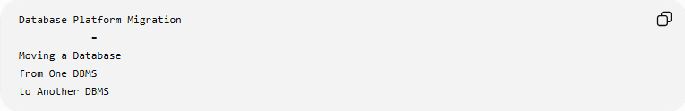
Database Platform Migration
=
Moving a Database
from One DBMS
to Another DBMS

📚 Common Platform Migrations
# Source: AI Source: Provided by: [Data Path: Persons Table -> ID Column: 1, Name_En Column: Motasem Essam] -> From: [ChatGPT] on [6/7/2026]
Example 1
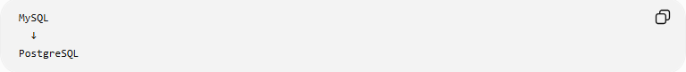
MySQL
↓
PostgreSQL

Example 2
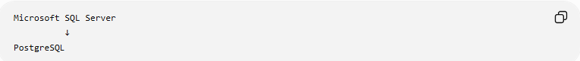
Microsoft SQL Server
↓
PostgreSQL

Example 3
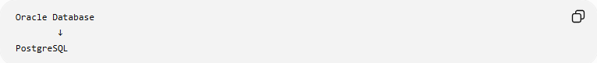
Oracle Database
↓
PostgreSQL

Example 4
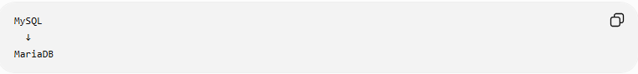
MySQL
↓
MariaDB

🏗️ What Gets Migrated?
# Source: AI Source: Provided by: [Data Path: Persons Table -> ID Column: 1, Name_En Column: Motasem Essam] -> From: [ChatGPT] on [6/7/2026]
A database contains more than just data.
During migration, the following may need to be transferred:
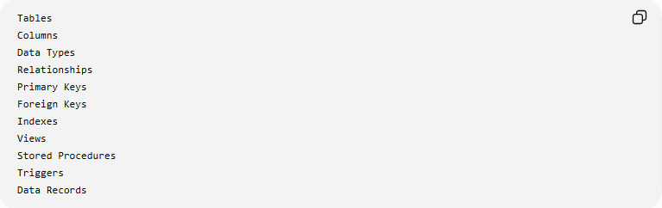
Tables
Columns
Data Types
Relationships
Primary Keys
Foreign Keys
Indexes
Views
Stored Procedures
Triggers
Data Records

🛠️ Example Migration
# Source: AI Source: Provided by: [Data Path: Persons Table -> ID Column: 1, Name_En Column: Motasem Essam] -> From: [ChatGPT] on [6/7/2026]
Source Database
MySQL
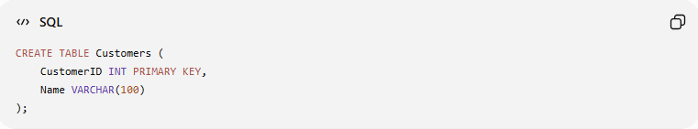
CREATE TABLE Customers (
CustomerID INT PRIMARY KEY,
Name VARCHAR(100)
);

Data
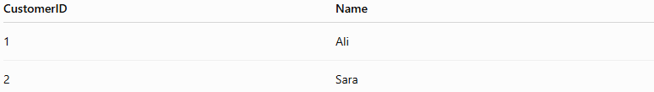
CustomerID | Name
1 | Ali
2 | Sara

Migration
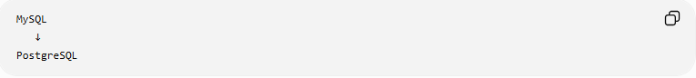
MySQL
↓
PostgreSQL

Destination Database
PostgreSQL
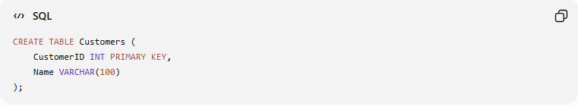
CREATE TABLE Customers (
CustomerID INT PRIMARY KEY,
Name VARCHAR(100)
);

Data
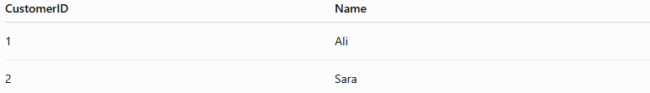
CustomerID | Name
1 | Ali
2 | Sara
The schema and data are preserved.

🔍 Common Migration Tasks

1️⃣ Schema Conversion
# Source: AI Source: Provided by: [Data Path: Persons Table -> ID Column: 1, Name_En Column: Motasem Essam] -> From: [ChatGPT] on [6/7/2026]
Different databases may use different SQL syntax.
MySQL
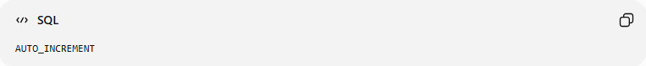
AUTO_INCREMENT

PostgreSQL
SERIAL
Schema definitions often need modification.

2️⃣ Data Type Conversion
# Source: AI Source: Provided by: [Data Path: Persons Table -> ID Column: 1, Name_En Column: Motasem Essam] -> From: [ChatGPT] on [6/7/2026]
Some data types differ between platforms.
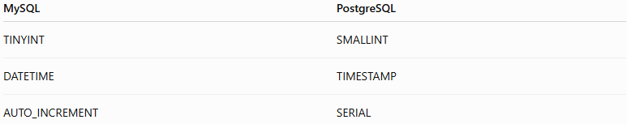
MySQL | PostgreSQL
TINYINT | SMALLINT
DATETIME | TIMESTAMP
AUTO_INCREMENT | SERIAL

Example:
MySQL
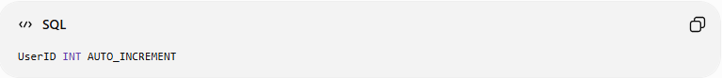
UserID INT AUTO_INCREMENT

PostgreSQL
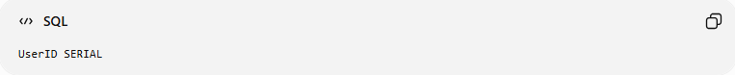
UserID SERIAL

3️⃣ Data Transfer
# Source: AI Source: Provided by: [Data Path: Persons Table -> ID Column: 1, Name_En Column: Motasem Essam] -> From: [ChatGPT] on [6/7/2026]
Copy actual records.
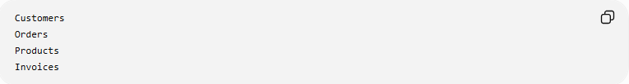
Customers
Orders
Products
Invoices

4️⃣ Procedure Conversion
# Source: AI Source: Provided by: [Data Path: Persons Table -> ID Column: 1, Name_En Column: Motasem Essam] -> From: [ChatGPT] on [6/7/2026]
Stored procedures may require rewriting.
MySQL
MySQL Procedure Syntax
↓
PostgreSQL
PL/pgSQL Syntax

5️⃣ Application Updates
# Source: AI Source: Provided by: [Data Path: Persons Table -> ID Column: 1, Name_En Column: Motasem Essam] -> From: [ChatGPT] on [6/7/2026]
Applications may need new connection settings.
Before
MySQL Driver

After
PostgreSQL Driver

🌍 Real-World Example
# Source: AI Source: Provided by: [Data Path: Persons Table -> ID Column: 1, Name_En Column: Motasem Essam] -> From: [ChatGPT] on [6/7/2026]
A company's website uses MySQL.
Current Setup
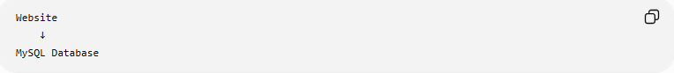
Website
↓
MySQL Database

As traffic grows:
Need Better Performance
Need Advanced Features

Migration:
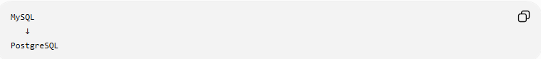
MySQL
↓
PostgreSQL

New Setup:
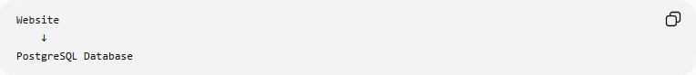
Website
↓
PostgreSQL Database

🔄 Database Platform Migration Lifecycle
# Source: AI Source: Provided by: [Data Path: Persons Table -> ID Column: 1, Name_En Column: Motasem Essam] -> From: [ChatGPT] on [6/7/2026]
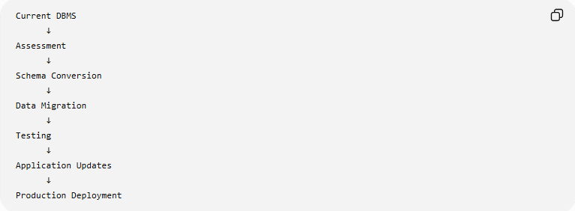
Current DBMS
↓
Assessment
↓
Schema Conversion
↓
Data Migration
↓
Testing
↓
Application Updates
↓
Production Deployment

⚠️ Common Challenges
# Source: AI Source: Provided by: [Data Path: Persons Table -> ID Column: 1, Name_En Column: Motasem Essam] -> From: [ChatGPT] on [6/7/2026]
SQL Syntax Differences
Example:
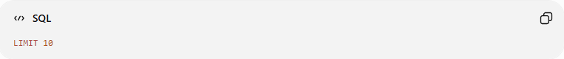
LIMIT 10
may work differently on some platforms.

Data Type Differences
Example:
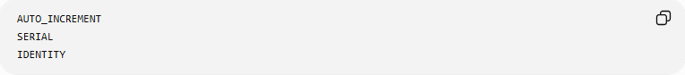
AUTO_INCREMENT
SERIAL
IDENTITY

Stored Procedures
Different procedural languages may be used.

Performance Tuning
Indexes and queries may need optimization after migration.

Application Compatibility
Database drivers and ORM settings may need updates.

📊 Platform Migration vs Data Migration
# Source: AI Source: Provided by: [Data Path: Persons Table -> ID Column: 1, Name_En Column: Motasem Essam] -> From: [ChatGPT] on [6/7/2026]
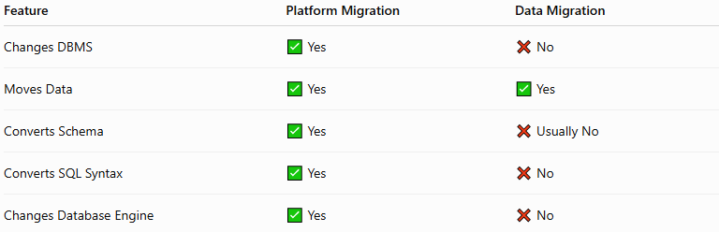
Feature | Platform Migration | Data Migration
Changes DBMS | ✅ Yes | ❌ No
Moves Data | ✅ Yes | ✅ Yes
Converts Schema | ✅ Yes | ❌ Usually No
Converts SQL Syntax | ✅ Yes | ❌ No
Changes Database Engine | ✅ Yes | ❌ No

Platform Migration Example
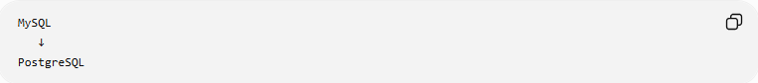
MySQL
↓
PostgreSQL

Data Migration Example
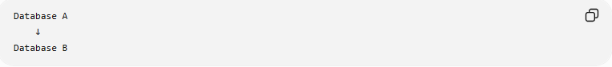
Database A
↓
Database B
Same DBMS, different location.

✅ Best Practices
# Source: AI Source: Provided by: [Data Path: Persons Table -> ID Column: 1, Name_En Column: Motasem Essam] -> From: [ChatGPT] on [6/7/2026]
Analyze Compatibility
Check:
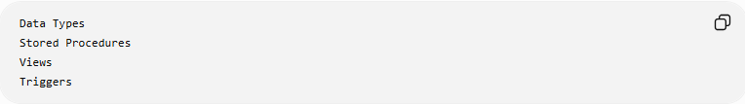
Data Types
Stored Procedures
Views
Triggers

Test Schema Conversion
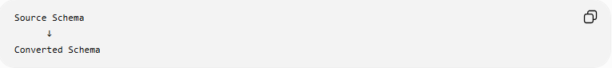
Source Schema
↓
Converted Schema

Validate Data
Verify:
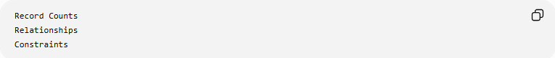
Record Counts
Relationships
Constraints

Run Performance Tests
Compare:
Before Migration
After Migration

Create Rollback Plans
Always prepare:
Migration Plan
Rollback Plan

🛠️ Common Database Platform Migration Tools
# Source: AI Source: Provided by: [Data Path: Persons Table -> ID Column: 1, Name_En Column: Motasem Essam] -> From: [ChatGPT] on [6/7/2026]
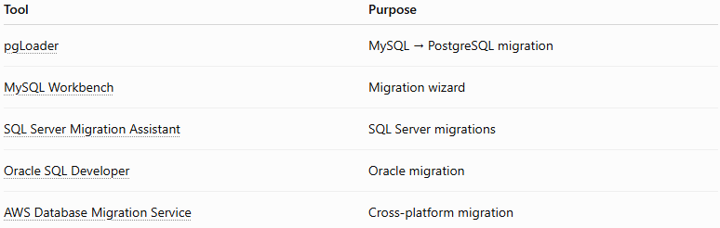
Tool | Purpose
pgLoader | MySQL → PostgreSQL migration
MySQL Workbench | Migration wizard
SQL Server Migration Assistant | SQL Server migrations
Oracle SQL Developer | Oracle migration
AWS Database Migration Service | Cross-platform migration

🧠 Simple Analogy
# Source: AI Source: Provided by: [Data Path: Persons Table -> ID Column: 1, Name_En Column: Motasem Essam] -> From: [ChatGPT] on [6/7/2026]
Think of moving from one smartphone brand to another.
Before
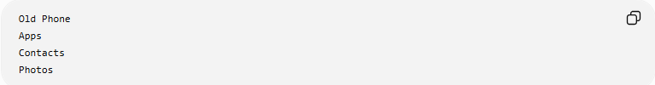
Old Phone
Apps
Contacts
Photos

Migration
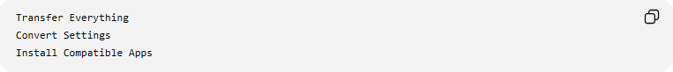
Transfer Everything
Convert Settings
Install Compatible Apps

After
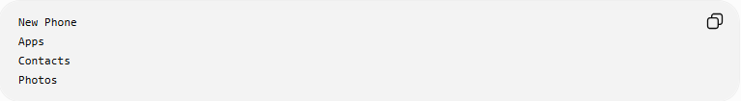
New Phone
Apps
Contacts
Photos
The device platform changes, but the information remains.
Database platform migration works the same way:
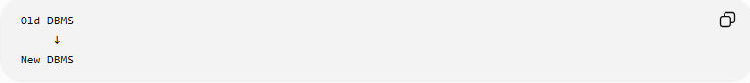
Old DBMS
↓
New DBMS
while preserving structure and data.

🧭 Summary
# Source: AI Source: Provided by: [Data Path: Persons Table -> ID Column: 1, Name_En Column: Motasem Essam] -> From: [ChatGPT] on [6/7/2026]
Database Platform Migration is the process of moving a database from one DBMS platform to another, such as MySQL → PostgreSQL, Oracle → PostgreSQL, or SQL Server → PostgreSQL. It involves migrating schemas, data, constraints, indexes, stored procedures, and application connections while handling differences in SQL syntax, data types, and database features. The goal is to improve performance, scalability, maintainability, or reduce costs while preserving data integrity and application functionality.

